Python Automated File Organizer
Introduction
The Automated File Organizer is a software solution developed to streamline digital workspace management. As digital storage environments grow, maintaining a structured file system becomes increasingly difficult. This project demonstrates the implementation of a Python-based automation system designed to autonomously scan, identify, and categorize files into designated folders based on their specific file types and extensions, providing an intuitive desktop interface for the user.
Problem Statement and Overview
Users frequently struggle with cluttered and disorganized directories, leading to decreased productivity, lost data, and significant manual effort spent sorting files. The manual categorization of large volumes of files is a repetitive, time-consuming task prone to human error. This project solves this issue by deploying an automated system that targets specific directories, detects file types via their extensions, and autonomously distributes them into systematically structured folders (e.g., Documents, Images, Videos, Code). This drastically reduces manual effort and improves system accessibility.
Tools and Applications Used
Programming Language: Python
User Interface: tkinter (Python's standard GUI library)
System Modules: os (for directory scanning, path manipulation, and folder creation), shutil (for executing file copy operations)
Utilities: datetime (for generating unique timestamped filenames to prevent data overwriting)
Detailed Description of Sub-Modules
- Graphical User Interface (GUI) Module: Built using tkinter, this module provides a user-friendly window where users can browse and select their desired source and destination directories without needing to interact with the command line.
- Directory Scanning & Validation Module: Utilizes os.walk() to deeply scan the selected source directory, identifying all underlying files while validating that the chosen paths exist.
- Classification & Categorization Module: Extracts the extension of each detected file using os.path.splitext(). It then cross-references this extension against a predefined dictionary mapping (e.g., .pdf to Documents, .py to Code) to determine the appropriate target category. Unrecognized extensions are routed to an "Other" category.
- File Operation & Execution Module: Automatically generates the necessary category folders in the destination directory. It safely copies the files using shutil.copy2(), appending a precise timestamp to each filename to ensure no existing files are accidentally overwritten during the transfer.

Design and Flow of the Project
Input: The user launches the application and selects the source folder (C:/Users/HELLO/OneDrive/Documents/tejaaiprogramme) and the destination folder (C:/Users/HELLO/OneDrive/Documents/tejaaiprogramme/javardhan reddy) via the GUI
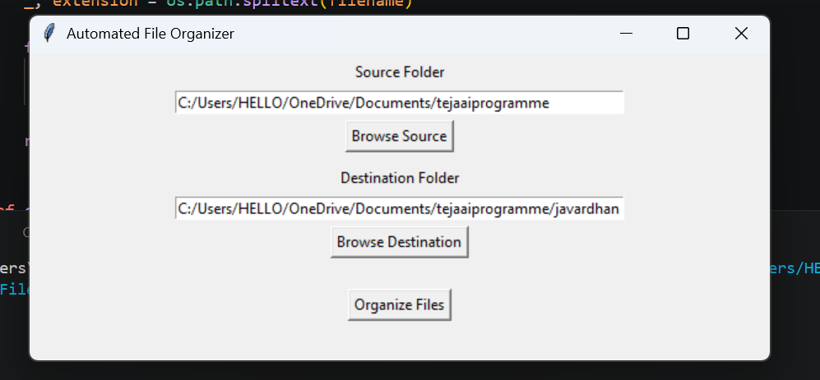.

Initialization: The system validates the input paths and generates the necessary categorized sub-folders in the destination directory.
Execution: The script iterates through every file in the source directory. For each file, it extracts the extension, determines the logical category, and constructs a new unique filename with a timestamp.
Transfer: The file is securely copied to its new categorized folder.
Output Generation: Upon completion, the system tallies the processed files and triggers a pop-up message notifying the user of the successful organization.
Conclusion and Expected Output:
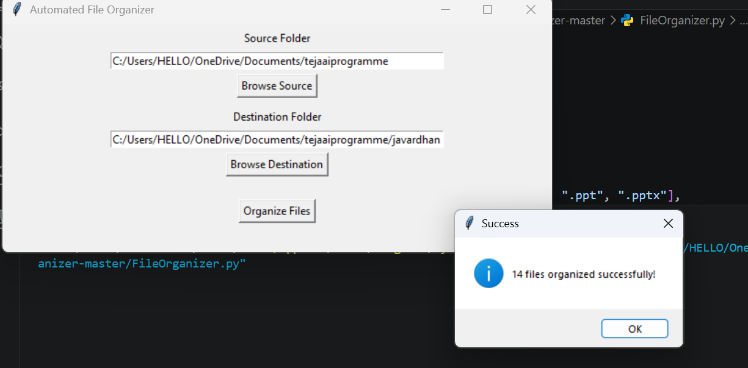
The expected output of this system is a completely restructured destination directory where all previously scattered files are neatly grouped into logical category folders. By eliminating repetitive file organization tasks, this automation project ensures reliable management of large datasets, maintains a clean directory layout, and significantly enhances user accessibility and productivity.

